**A compact Umbrella shaped Stretchable with Circular Slots for Bio-medical applications**

Neeraj Kumar, Vinod Kumar Singh Shalini Upadhyay, Nidhi Patel, Chandan Maddheshiya, Ritik Viswakarma, Sumit Narayan Singh

Corresponding Author: singhvinod34@gmail.com

**Abstract:** The usage of Wearable devices and products is currently increasing in biomedical field. The presented antenna is suitable for monitoring, alerting and demanding attention during any hospital emergency. This ultra-wide band (UWB) flexible umbrella shape body worn antenna is fabricated on a jean’s material as a substrate. The incarnated antenna has a -10dB measured impedance band width of 1309MHz.The antenna size is 64.2 × 77.2 mm2. The radiation effect emitted by the presented antenna on the human body is given by the calculation of specific absorption rate (SAR) value. The result in terms of band width, return loss, radiation pattern along with gain and efficiency are presented to validate functionality of current proposed design.

**Key Words:** Body worn antenna, efficiency, textile antenna, return loss, SAR

1. **Introduction**

Wearable computing is a fast-growing field in application based research [1]. This technology which allows devices to be worn directly on the body or embedded in clothing when designed on textile, should have low dielectric constant which in result improves the impedance band width of the antenna. The textile material that we are using can either be artificial man-made or natural fibers, the jeans material is a synthetic man-made fibre. The important properties can be calculated using simulation software Computer Simulation Technology (CST) microwave studio suite. Ultra-wide band is a showing up wireless technology approved by Federal Communications Commission (FCC) for commercial use of frequency band from 3.1to 10.6 GHz.UWB antennas have several applications such as biomedical, microwave imaging, internet of thing and wireless local area network. Over a period of time, flexible antennas have been used for producing microwave imaging by placing on the human body surface for biomedical application. Due to difference in dielectric properties of healthy and baleful tissues, the electromagnetic wave interacts and they produce different microwave images a circular shape radiator UWB is presented, which is design with 100% cloth for body-oriented wireless application. Since, it is design on cloth it can be washed if the conductive part is made up of conductive thread available in market.

The proposed simulation explains the design of compact low cast, flexible, high gain and efficiency antenna with UWB range which will be fabricated on cloth for health monitoring functions. The basic shape of antenna is semi-circular because circular shape antennas have better performance than rectangular shape antenna [2]. The patch we have selected resembles umbrella, which can be easily designed and implanted on cloth. One of the measure characteristics that must be taken in consideration by any wearable antenna is the low specific absorption rate [3,4]. It is necessary to measure and evaluate SAR because human body will absorb and get affected by the back radiation emitted by the antenna.

The rest of the paper is planned as follows. It majorly has five more sections divided. The design of UWB antenna detail is discussed in section 2. This section comprises of antenna description and simulation environment. The performance analysis, surface current and radiation pattern, banding effect is described in section 3, 4 and 5 respectively. Finally, the conclusions and further work is discussed in last section.

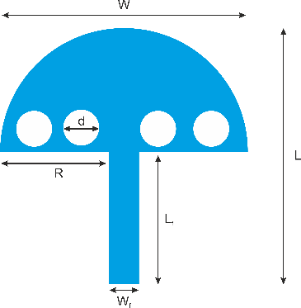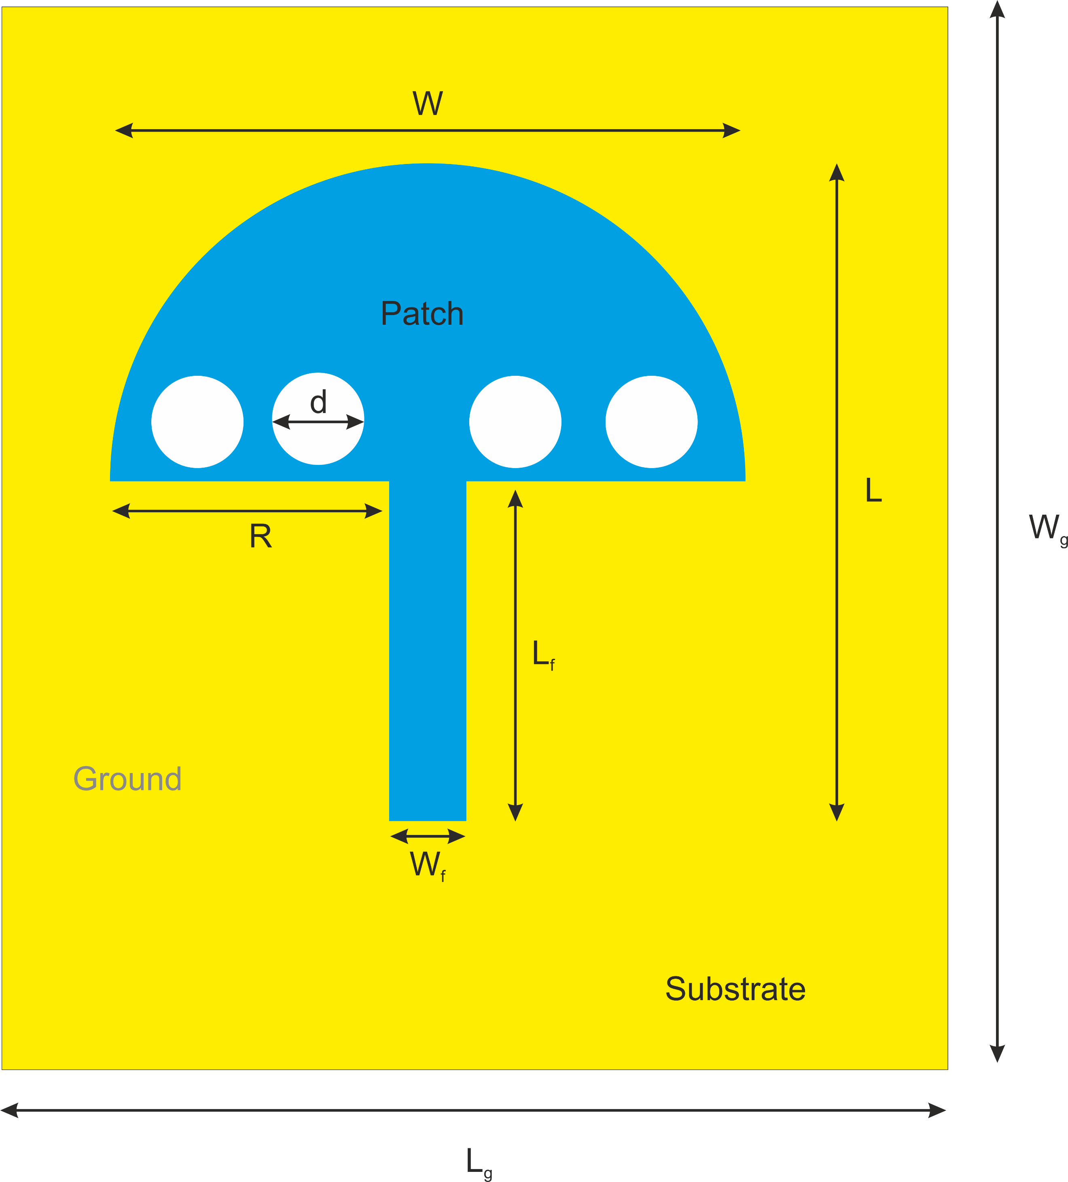

1. **Antenna design description**

|  |  |  |  |  |
| --- | --- | --- | --- | --- |
| **Parameter** | **L** | **W** | **R** | **d** |
| Value (mm) | 78.2 | 65.2 | 23 | 10 |
| **Parameters** | **Lf** | **Wf** | **Lg** | **Wg** |
| Value (mm) | 49.6 | 2.5 | 78.2 | 65.2 |

The umbrella shaped antenna is made out from a basic circular patch. To increase the bandwidth of basic circular patch antenna, slots can be embedded and defected ground technique on the periphery of the patch antenna can be used [5, 6]. The substrate of the proposed antenna is made of jeans of thickness 1mm. The reason behind using jeans as a substrate is that in enhances bandwidth and reduces the surface wave losses due to its low dielectric constant [7, 8]. The overall dimension of the antenna is 65.2 × 78.2 × 1 mm3**.** The radius of the patch is calculated as per equation (1). The dielectric permittivity (Ɛr), thickness (t) and loss tangent (tanδ) values are shown in Table 1. The geometry of the proposed antenna is shown in Figure 1(a). Figure 1(a) shows the parameters mentioned in Table 2. Figure 1(b) shows the final front view of the antenna.

 (1)

|  |  |
| --- | --- |
| Textile material | Values |
| Dielectric permittivity | 1.76 |
| Thickness | 1.0 mm |
| Loss tangent | 0.025 |

(a) (b)

Figure1. Simulation models (a) Parametric view (b) Back view.

Table 2 Parameters of proposed design

1. **Performance analysis**

Here CST softwareis used for simulation of the antenna. The simulation results are shown further the designed antenna has a simulated impedance bandwidth from 2.9 GHz to 18GHz with three resonance frequencies: f1= 3.14 GHz, f2=4.42 GHz and f3=10.71 GHz.The antenna that we have design has enhanced impendence bandwidth and serves the purpose.

Figure 2 Simulated Return Loss of designed antenna.

**4. Surface current and radiation pattern**

The current density of the preposed antenna at resonant frequency at f1=3.14, f2= 4.42 and f3=10.17 is given in figure 3. At 3.14 GHz, it can be seen that most of current having amplitude 83.2 A/m as shown in figure 7a. At 4.42 GHz the amplitude of surface current is 40.7 A/m as shown in figure 7b. While at 10.71 GHz the surface current is having amplitude only 36.6 A/m .

In figure 4, the radiation pattern of proposed antenna is given at 3.14 GHz, 4.42 GHz and 10.71 GHz respectively. The 3D radiation pattern gives us the directivity at resonant frequencies. The radiation pattern for 3.14 GHz is given in figure 4a. The directivity at 4.42 GHz and 10.71 GHz is given in figure 8b and 8c respectively.

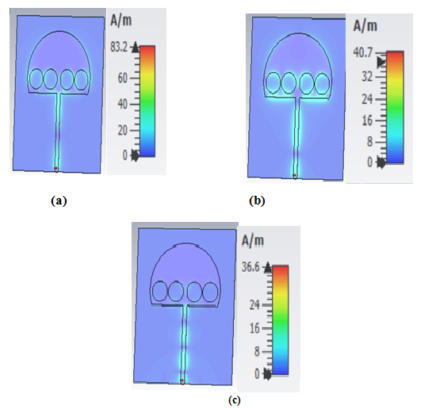

Figure 3 Simulated surface current at (a) 3.14 GHz (b) 4.42 GHz (c) 10.71 GHz

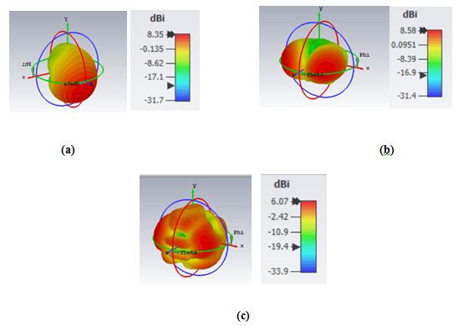

Figure 4 Simulated 3D Radiation pattern at (a) 3.14 GHz (b) 4.42 GHz (c) 10.71 GHz

**Conclusion**

A umbrella shaped quad slotted antenna is designed for biomedical applications. The antenna with overall size of 65.2 × 78.2 × 1 mm3 achieves -10dB of impedance bandwidth of 1309 MHz. The designed antenna is suitable for human body. In future, this antenna can be integrated with sensors to perform several multitask applications such as measuring blood pressure, hearth rate and much more.

# References

1. T. E. Starner, “Wearable computing for the developing world,” IEEE Pervasive Comput., vol. 4, pp. 87–91, Jul.–Sep. 2005.
2. Dalli A, Zenkouar L, Bri S. Comparison of circular sector and rectangular patch antenna arrays in C-band. J Electromagn Anal Appl. 2012;4(11):457-467. doi:10.4236/jemaa.2012.411064
3. Keshvari J, Keshvari R, Lang S. The effect of increase in dielectric values on specific absorption rate (SAR) in eye and head tissues following 900, 1800 and 2450 MHz radio frequency (RF) exposure. Phys Med Biol. 2006;51(6):1463-1477. doi:10.1088/0031-9155/51/6/007
4. Takebayashi T, Varsier N, Kikuchi Y, et al. Mobile phone use, exposure to radiofrequency electromagnetic field, and brain tumour: a case-control study. Br J Cancer. 2008;98(3):652-659. doi:10.1038/sj.bjc.6604214
5. Jayalakshmi J, Ramesh S. Compact fractal wearable antenna for wireless body area communications. Telecommun Radio Eng. 2020; 79(1):71-80. doi:10.1615/TelecomRadEng.v79.i1.70
6. Annalakshmi T, Ramesh S. Performance and analysis of UWB aesthetic pattern textile antenna for WBAN applications. Appl Comput Electromagn Soc J. 2020;35(12):1525-1531. doi:10.47037/2020.ACES.J.351211
7. Rahman A, Islam MT, Singh MJ, Kibria S, Akhtaruzzaman M. Electromagnetic performances analysis of an ultra-wideband and flexible material antenna in microwave breast imaging: to implement a wearable medical bra. Sci Rep. 2016;6(38906):1-11. doi:10.1038/ srep38906
8. Tighezz M, Rahim SKA, Islam MT. Flexible wideband antenna for 5G applications. Microw Opt Tech Lett. 2018;60(1):38-44. doi:10.1002/ mop.30906
9. Mersani A, Osman L, Ribero J-M. Flexible UWB AMC antenna for early stage skin cancer identification. Progress Electromagn Res M. 2019; 80:71-81. doi:10.2528/PIERM18121404
10. Arifin F, Saha PK. Bandwidth enhancement of a compact planar antenna for wireless capsule endoscopy. 2016 9th international confere